**Finalizing Semester Grades**

**At a Glance**

**To finalize semester grades, you must do the following:**

1. **Clear ALL previous comments.**
2. **Add citizenship grades for classes that are given letter grades using the comment. Citizenship is the ONLY comment allowed in the final grade column**. When a score has a comment, it is labeled with a little blue indicator. Classes that do not get a letter grade (i.e. study hall, advisor/case manager) should not be given citizenship grades.
3. **Manually override grades if approved.**
4. **Finalize by clicking submit button for each class**

**Please Read ALL Steps!!!**

**A. Clear Previous Comments**

IMPORTANT: REMOVE ANY COMMENTS in the Final Grade column. You may do this individually, or by class. When a comment exists, it is labeled with a little blue indicator.

To clear all previous comments in any given class:

1. Right click on a final grade and choose Fill Scores.

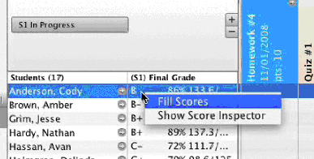

2. Overwrite with a blank comment

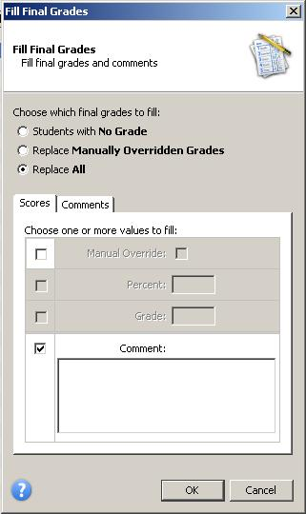

Select Replace All

This comment box MUST be left (or made) blank before selecting OK.

**This will overwrite all comments you have entered for individual students with a blank.**

Select OK when you are finished.

**FYI:**

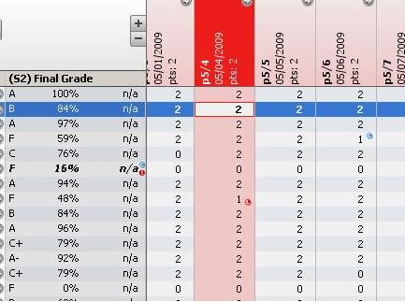

Comments in the Final Grade column need to be cleared

Comments for individual assignments DO NOT need to be cleared

**B. Add Citizenship Grade**

(The only thing in the Final Grade column comment box should be citizenship)

1 = good; 5 = not good

1. Right click on the first final grade and choose Show Score Inspector.



2. Select the Comment tab.

Use these arrows to navigate through student names.

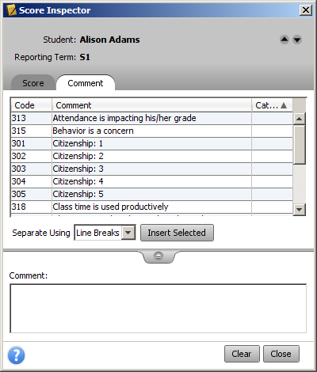

3. Insert appropriate citizenship grades by double clicking on them or selecting Insert Selected.

4. Use the arrows at the top right of the Score Inspector to navigate through student names.

**You will know citizenship grades are entered when** you see a little blue “C” mark near each student in the Final Grade column.

**C. If you have been given approval to change a grade manually, use Score Inspector.**

1. Right click on the appropriate final grade and choose Show Score Inspector.



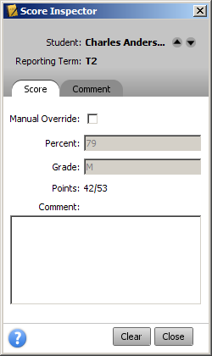

Check the manual Override checkbox

Enter a different

Percent or Grade

The only comment should be citizenship

Remember, the only comment to be added is citizenship

You can switch student by using the up & down arrow

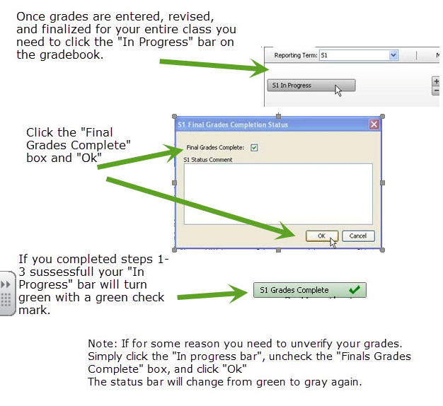**D. Finalize and Submit Grades**